Timer
# Source: AI Source: Provided by: [Data Path: Persons Table -> ID Column: 1, Name_En Column: Motasem Essam] -> From: [ChatGPT] on [7/17/2026]
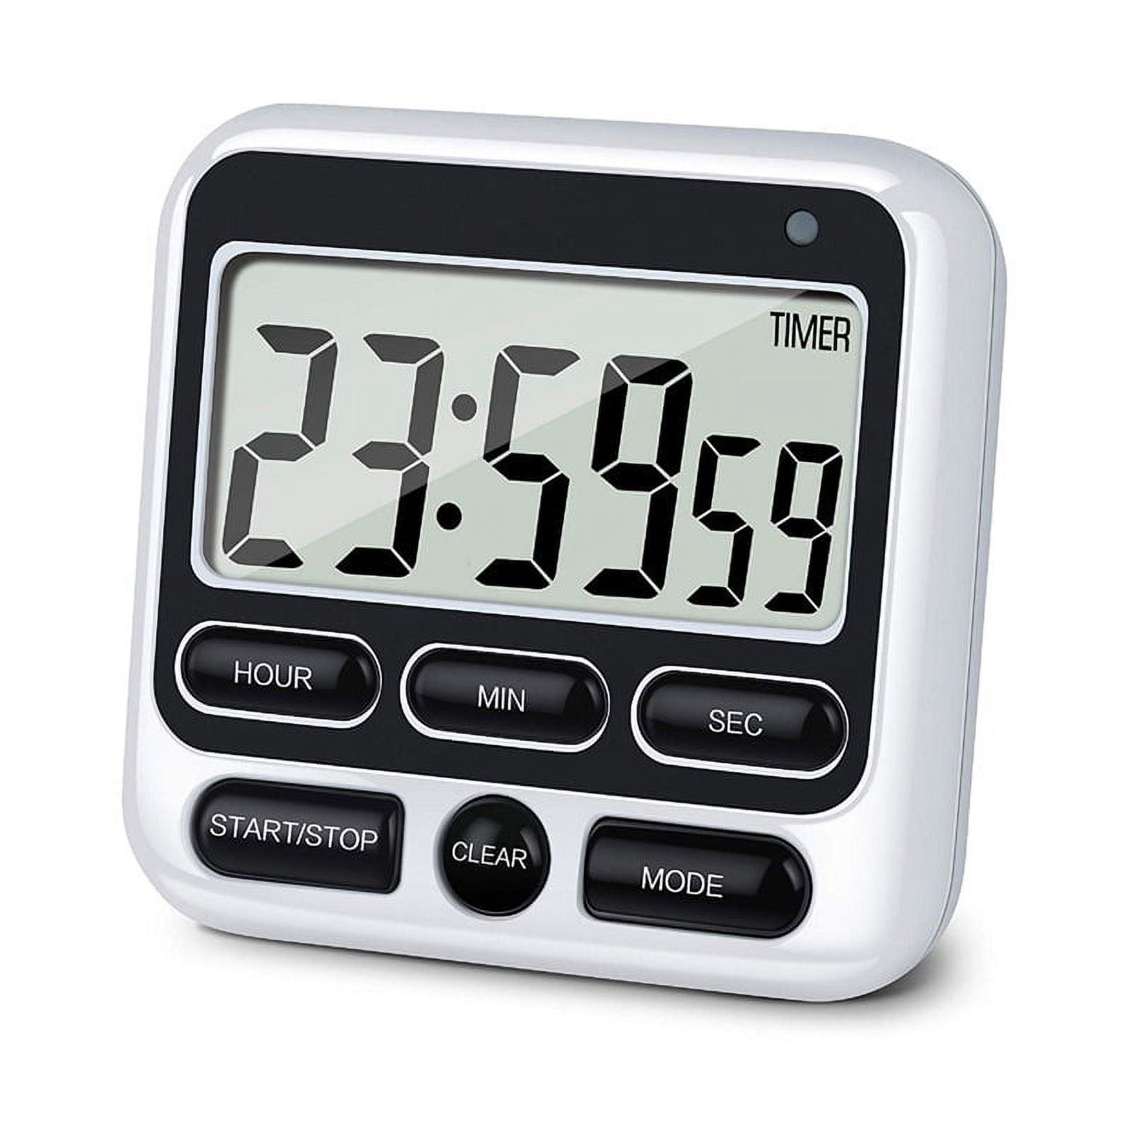
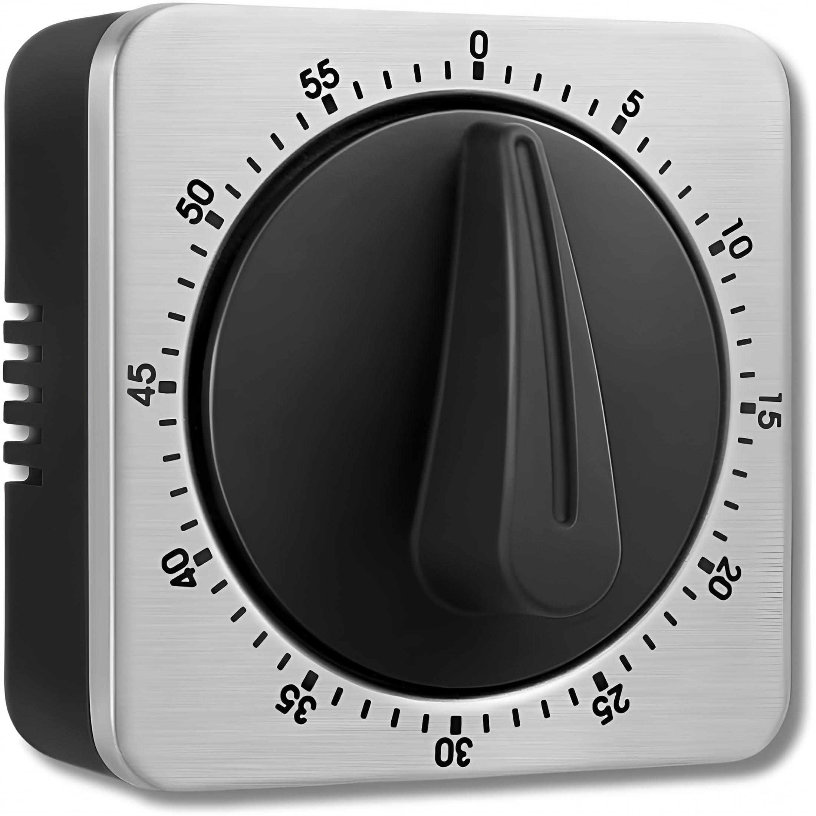
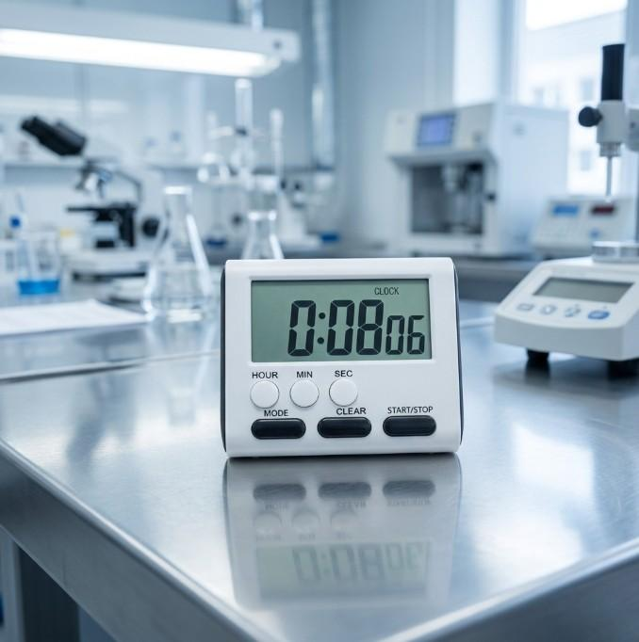
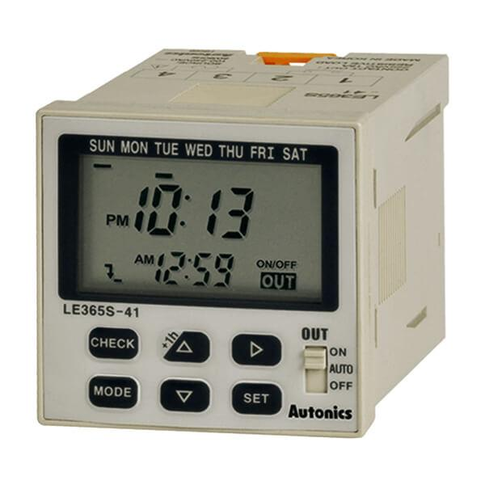
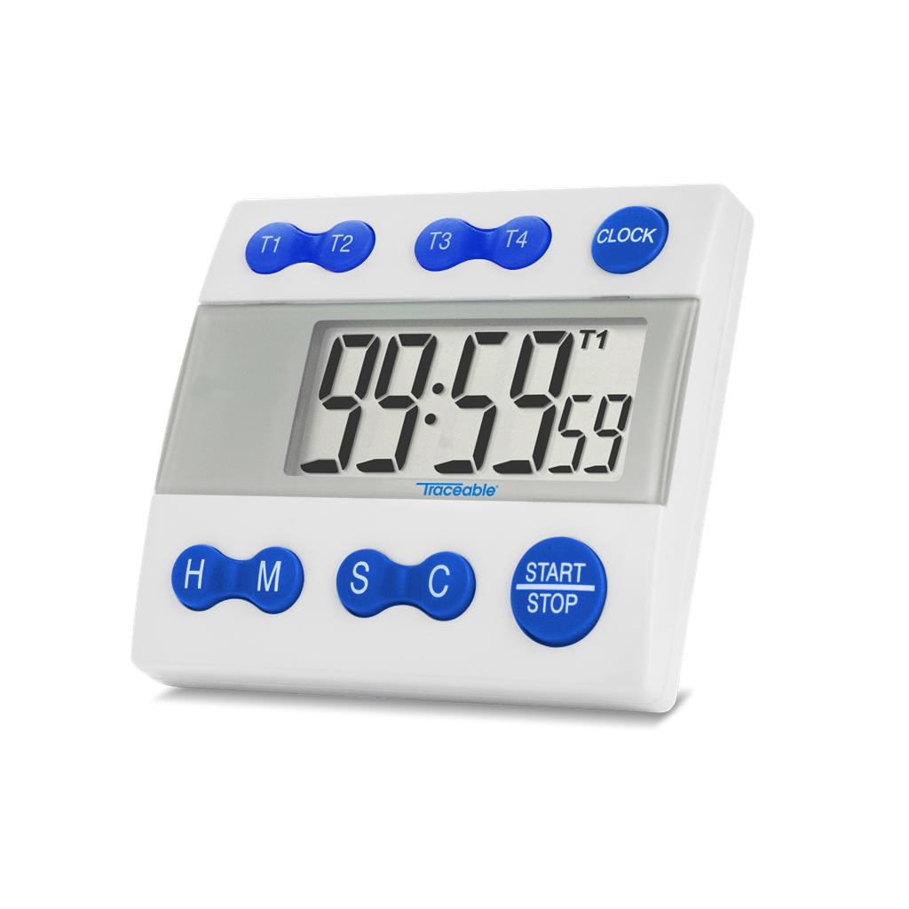
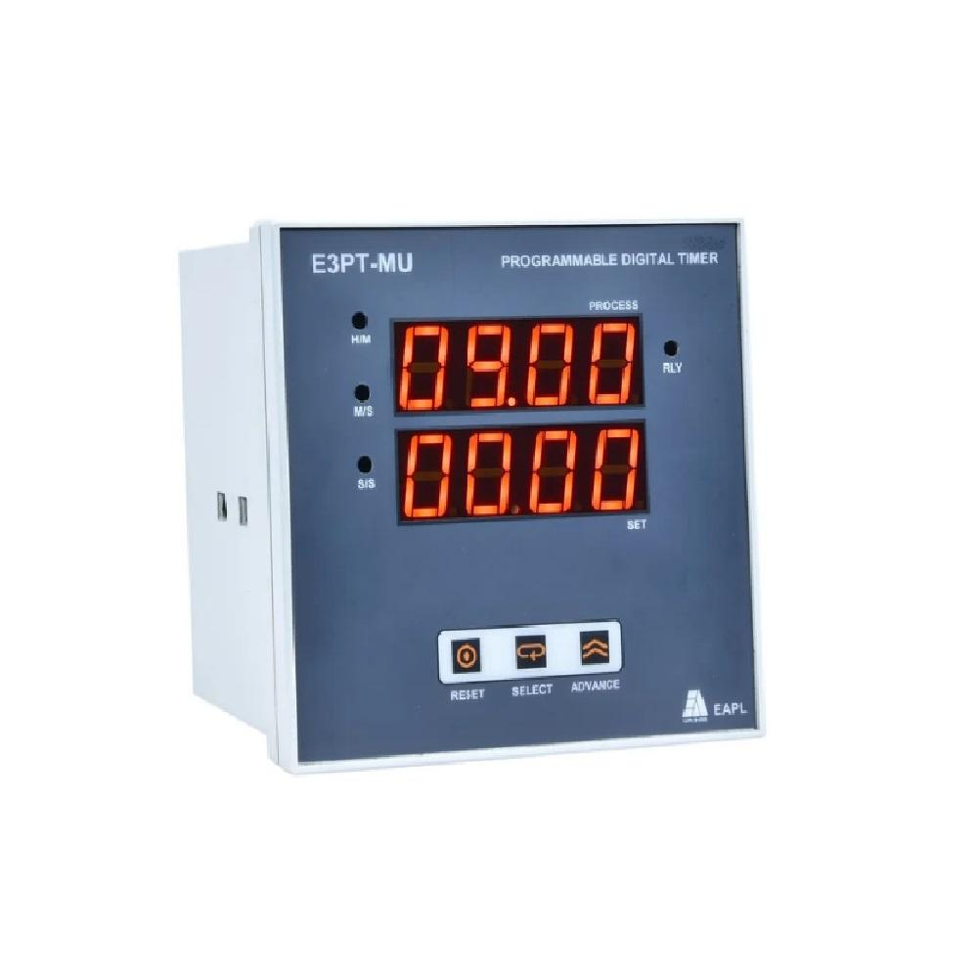
A Timer is a time-measuring instrument designed to measure or control a specified time interval. Unlike a clock, which continuously displays the current time, or a stopwatch, which measures elapsed time from a starting point, a timer is typically used to count down from a preset duration or, in some models, to count elapsed time.
Timers are widely used in homes, laboratories, industries, manufacturing, cooking, sports, medicine, electronics, and automation systems.

Definition
# Source: AI Source: Provided by: [Data Path: Persons Table -> ID Column: 1, Name_En Column: Motasem Essam] -> From: [ChatGPT] on [7/17/2026]
A Timer is a time-measuring instrument that counts down or measures a predefined time interval and often provides a visual or audible signal when the interval has elapsed.

Purpose
# Source: AI Source: Provided by: [Data Path: Persons Table -> ID Column: 1, Name_En Column: Motasem Essam] -> From: [ChatGPT] on [7/17/2026]
A timer is used to:
- Measure fixed time intervals.
- Count down to zero.
- Control equipment operation.
- Schedule automatic processes.
- Time cooking and baking.
- Conduct laboratory experiments.
- Manage sports training intervals.

Principle of Operation
# Source: AI Source: Provided by: [Data Path: Persons Table -> ID Column: 1, Name_En Column: Motasem Essam] -> From: [ChatGPT] on [7/17/2026]
The operating principle depends on the timer type:
- Mechanical timers use gears and springs to measure a preset duration.
- Electronic timers use quartz oscillators and digital circuits to count time accurately.
- Programmable timers use microprocessors to control equipment according to preset schedules.

Main Components
# Source: AI Source: Provided by: [Data Path: Persons Table -> ID Column: 1, Name_En Column: Motasem Essam] -> From: [ChatGPT] on [7/17/2026]
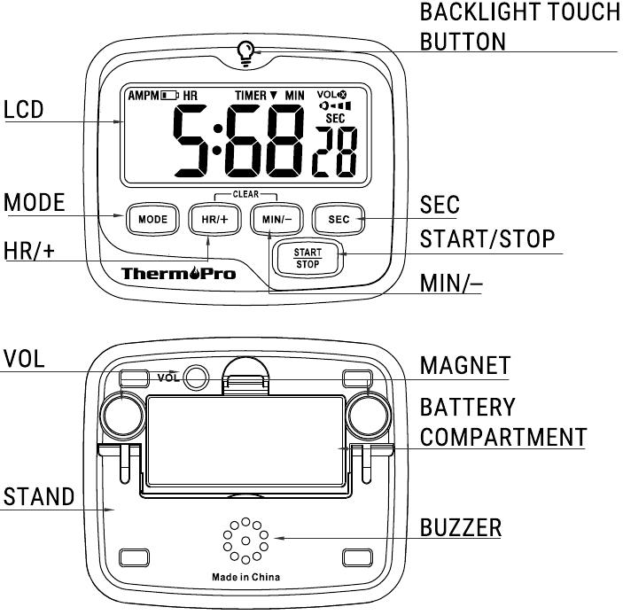
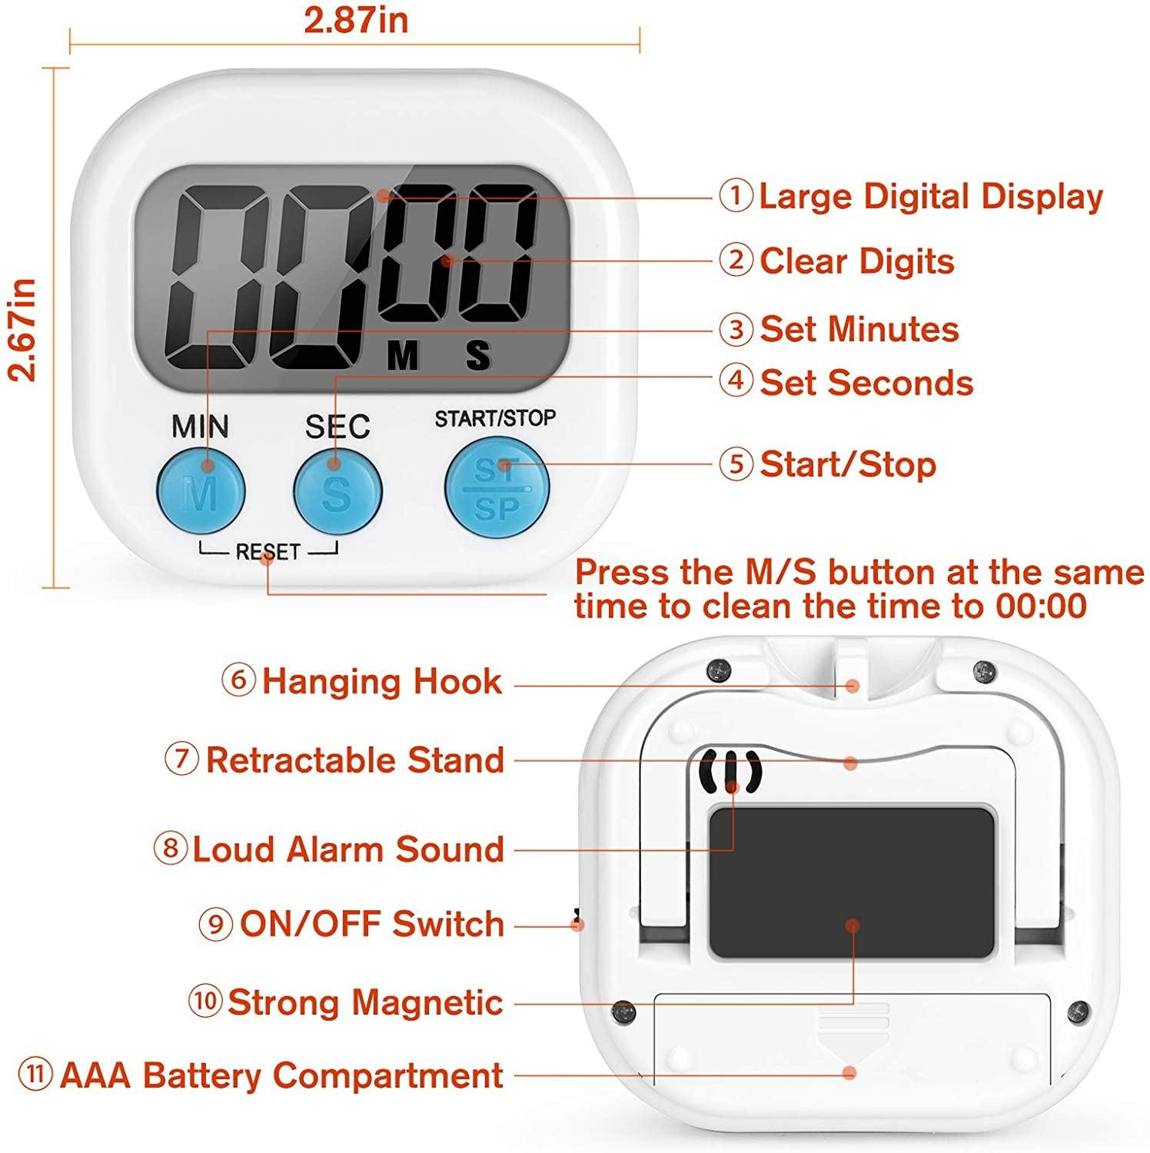
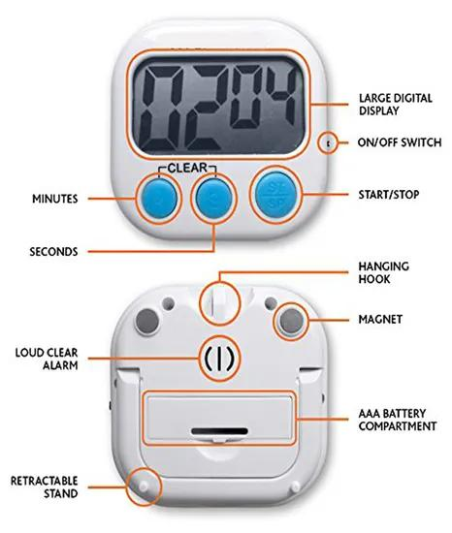
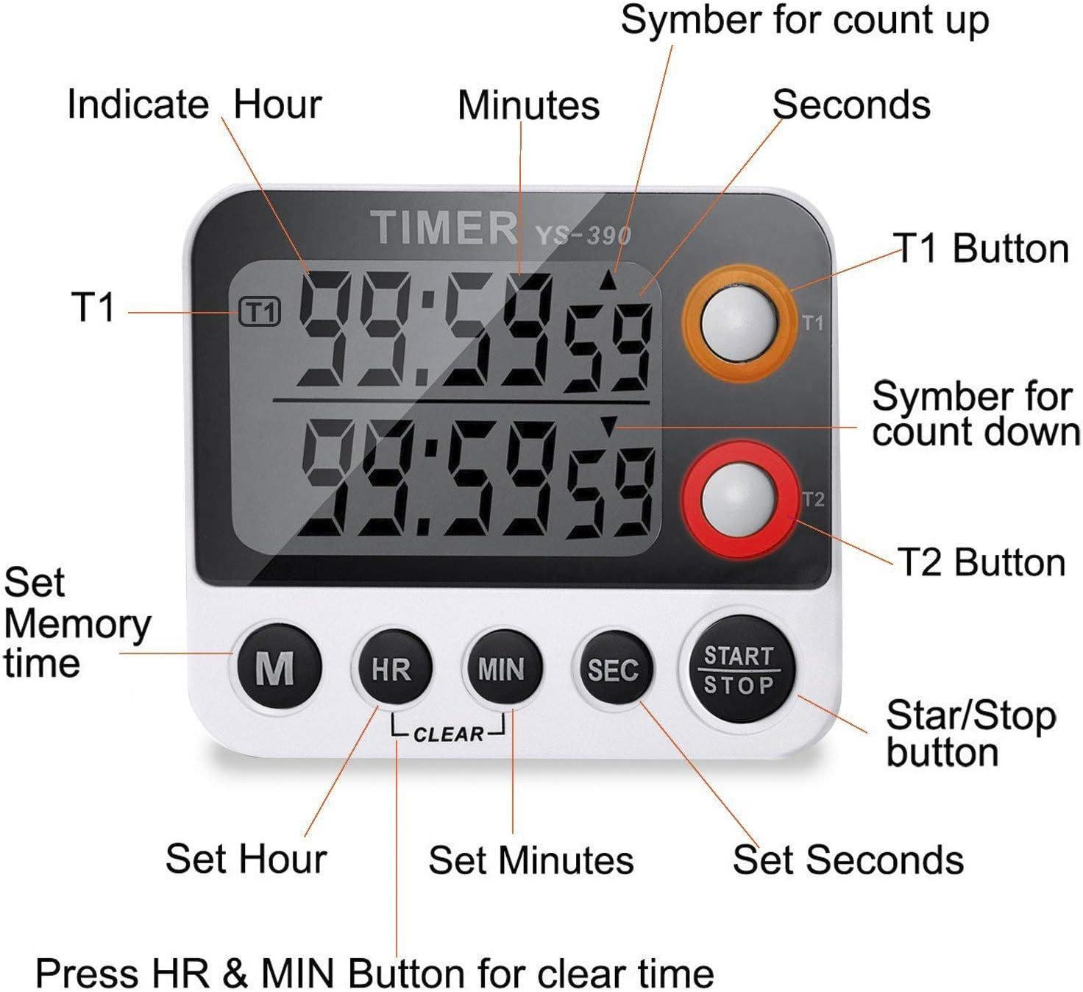
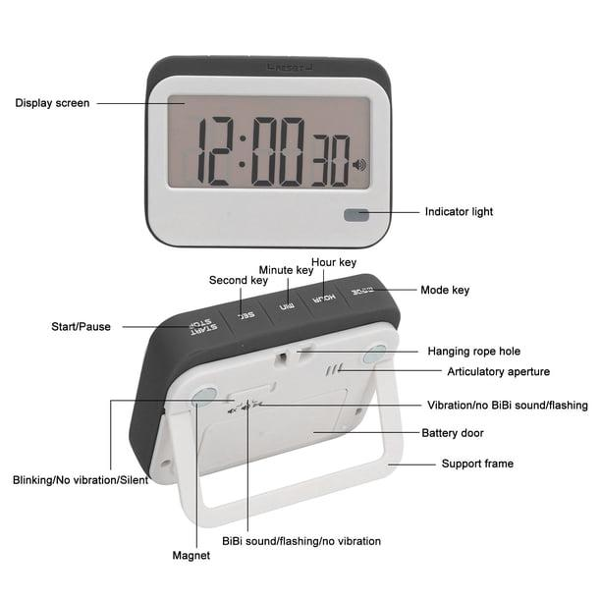
A typical timer consists of:
- Display (LCD, LED, or analog dial)
- Start button
- Stop button
- Reset button
- Time-setting buttons or dial
- Internal timing circuit or mechanism
- Alarm or buzzer
- Battery or power supply

Types of Timers

1. Mechanical Timer
# Source: AI Source: Provided by: [Data Path: Persons Table -> ID Column: 1, Name_En Column: Motasem Essam] -> From: [ChatGPT] on [7/17/2026]

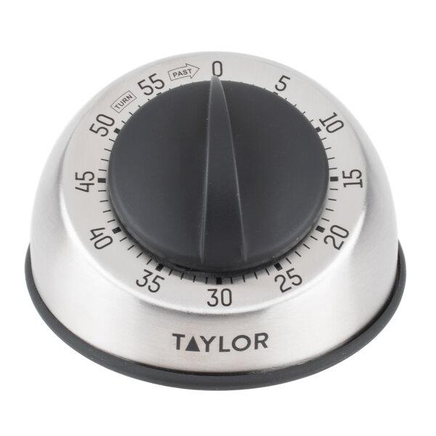
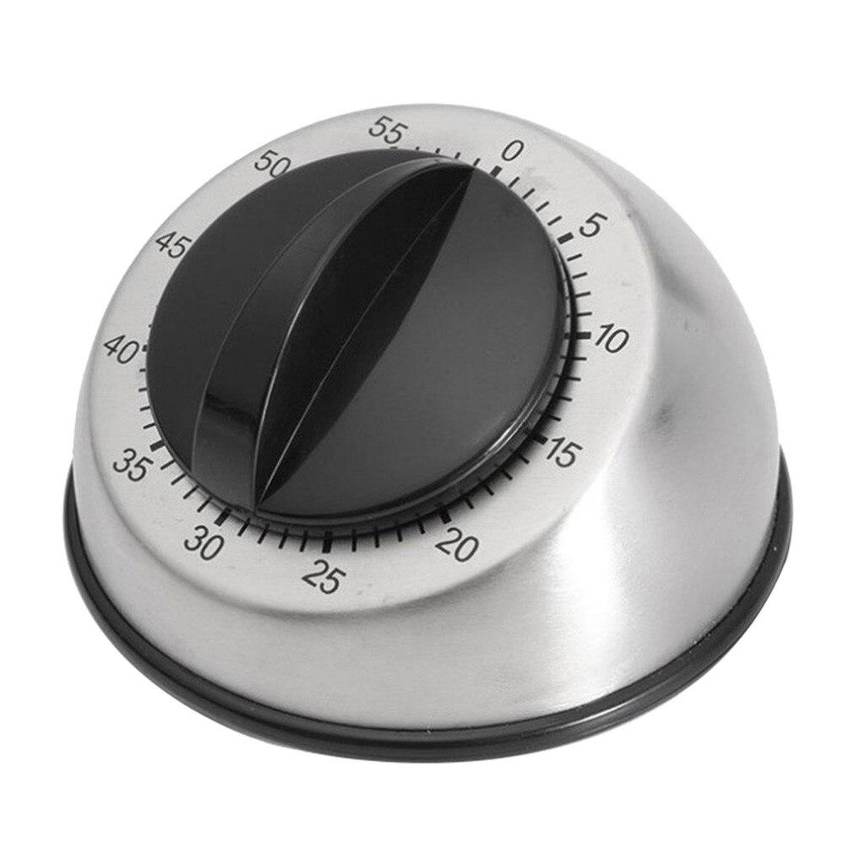
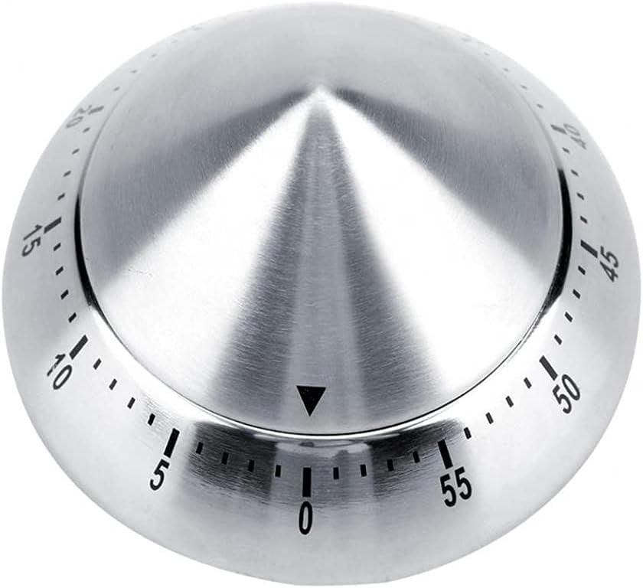
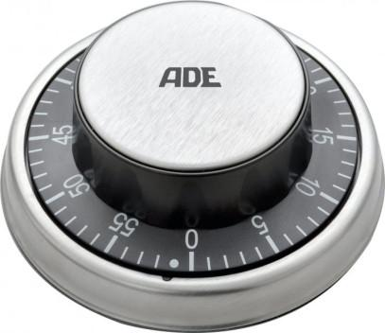
Description
Uses a spring-driven mechanism and rotating dial to count down.
Features
- No batteries
- Audible bell
- Simple operation
Applications
- Cooking
- Household use

2. Digital Timer
# Source: AI Source: Provided by: [Data Path: Persons Table -> ID Column: 1, Name_En Column: Motasem Essam] -> From: [ChatGPT] on [7/17/2026]
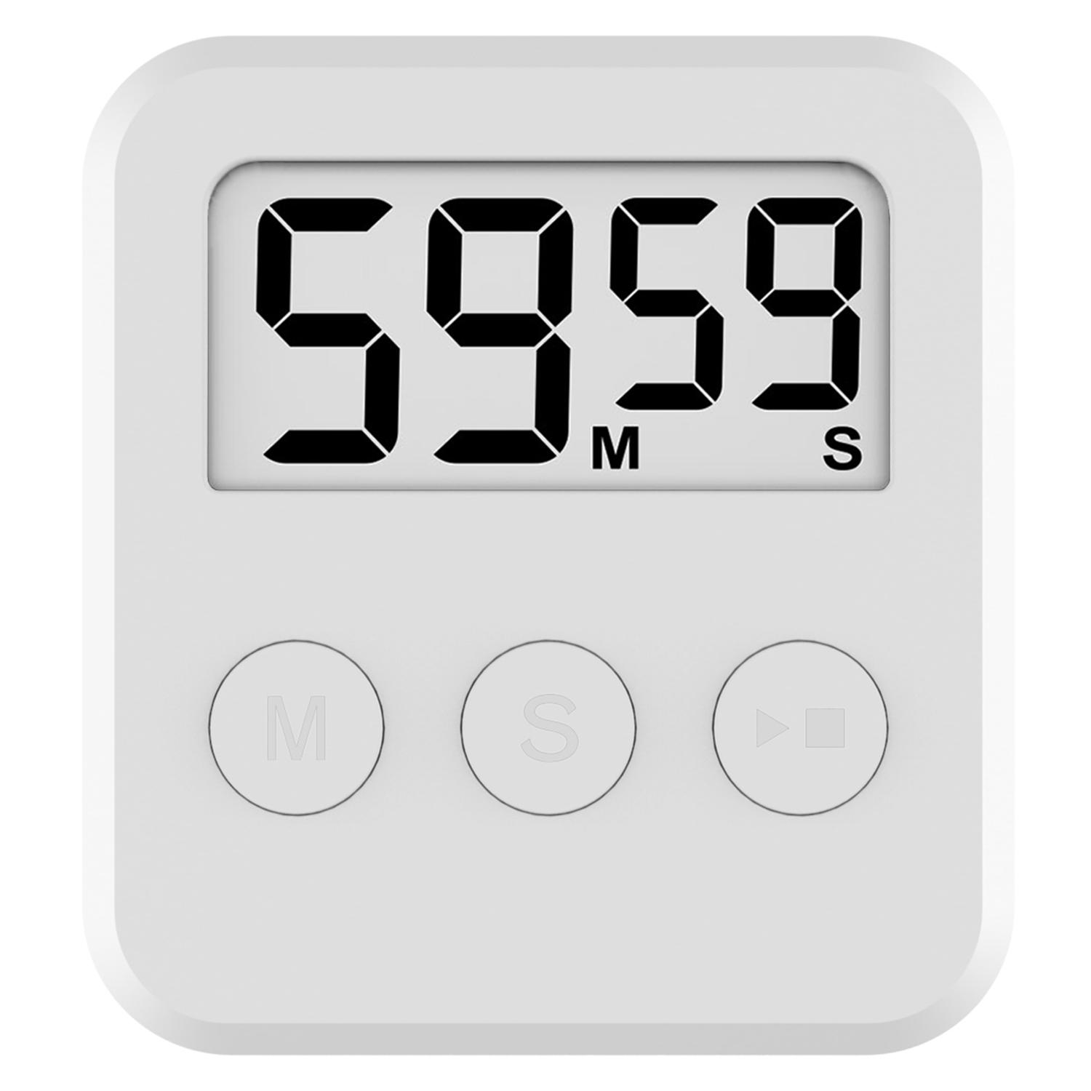

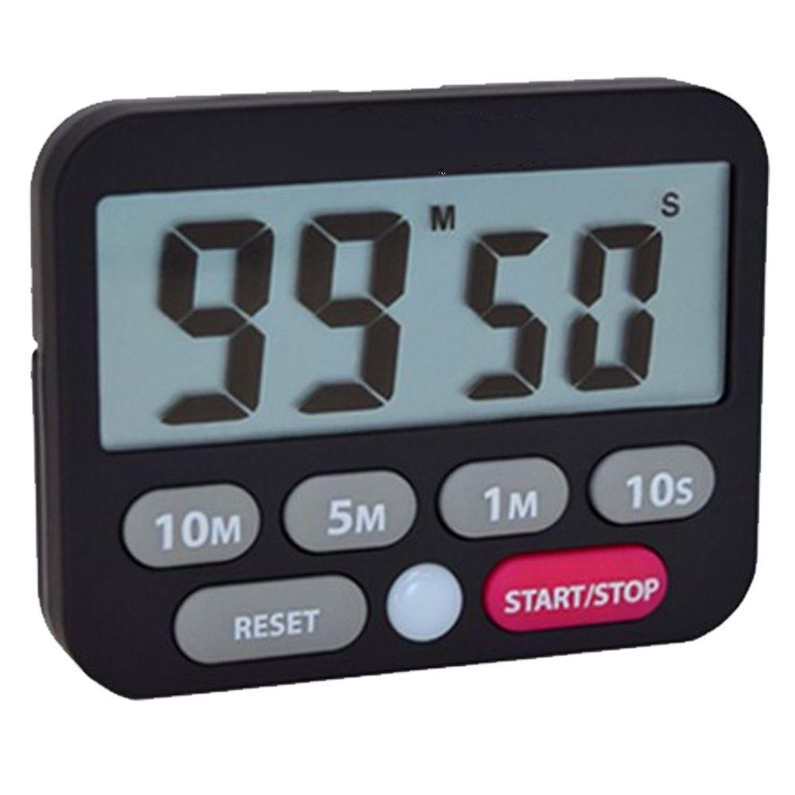
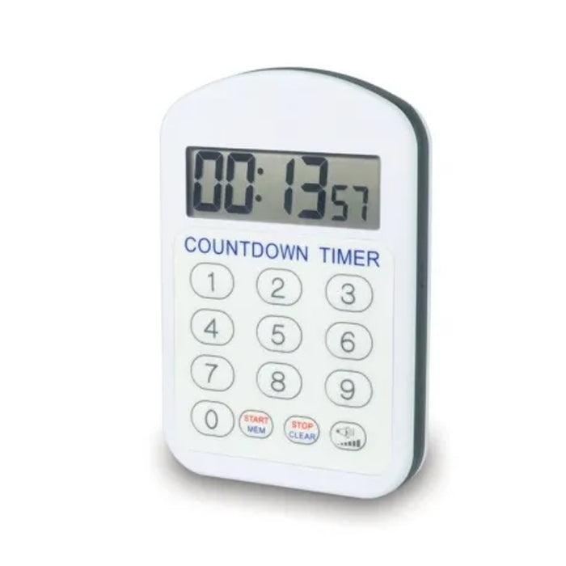
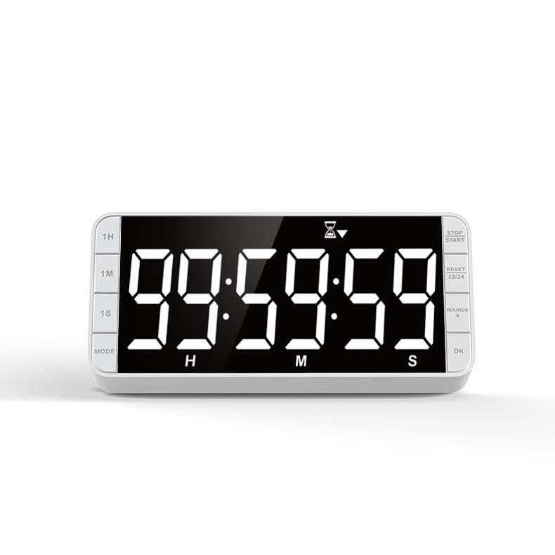
Description
Uses electronic circuits and a digital display.
Features
- High accuracy
- Countdown and count-up modes
- Audible alarm
- Easy-to-read display
Applications
- Laboratories
- Education
- Sports
- Cooking

3. Kitchen Timer
# Source: AI Source: Provided by: [Data Path: Persons Table -> ID Column: 1, Name_En Column: Motasem Essam] -> From: [ChatGPT] on [7/17/2026]
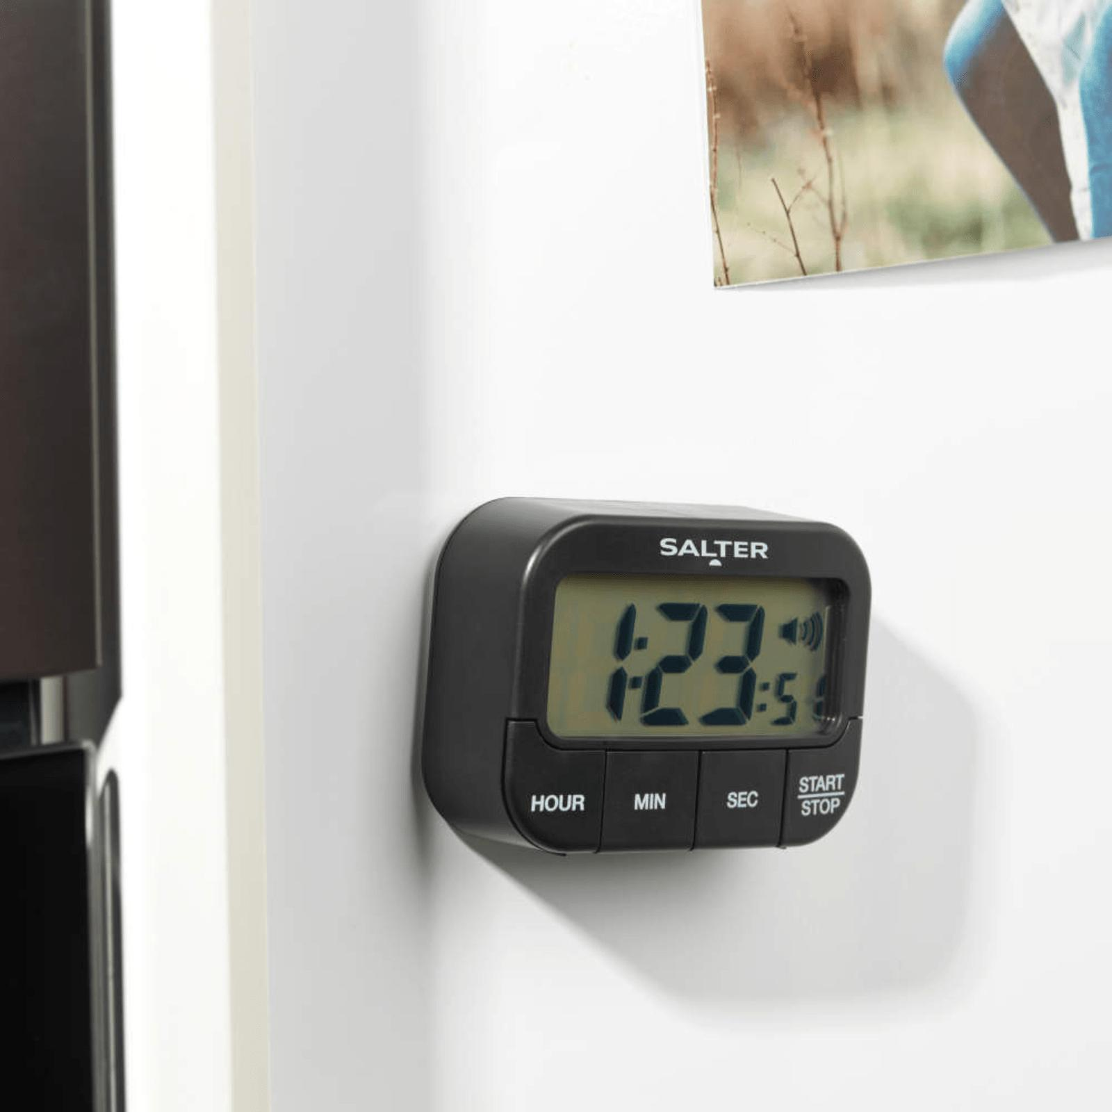
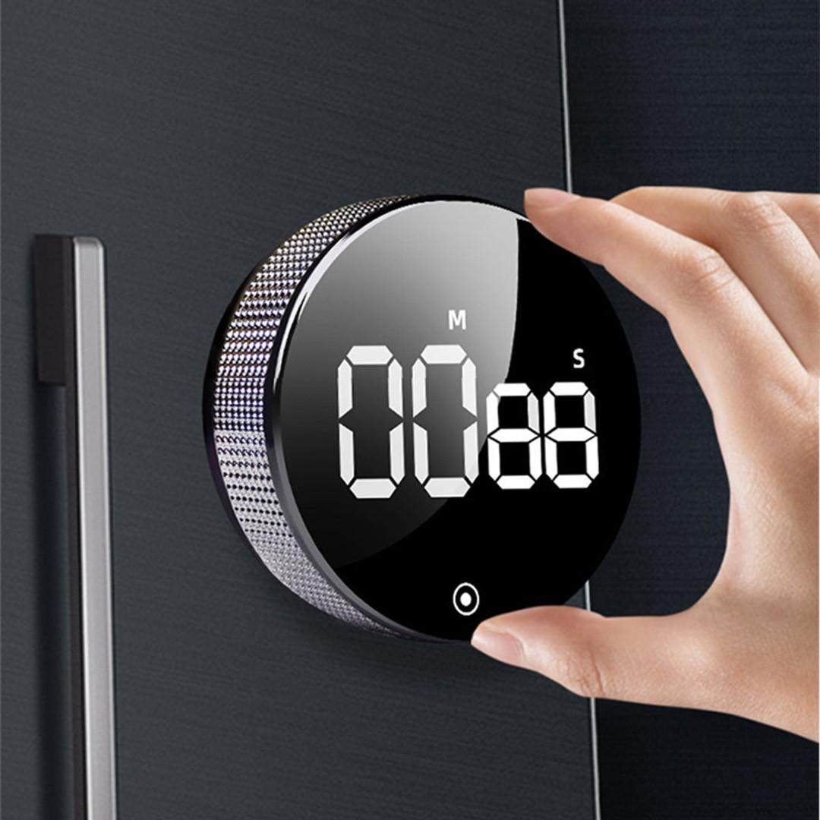
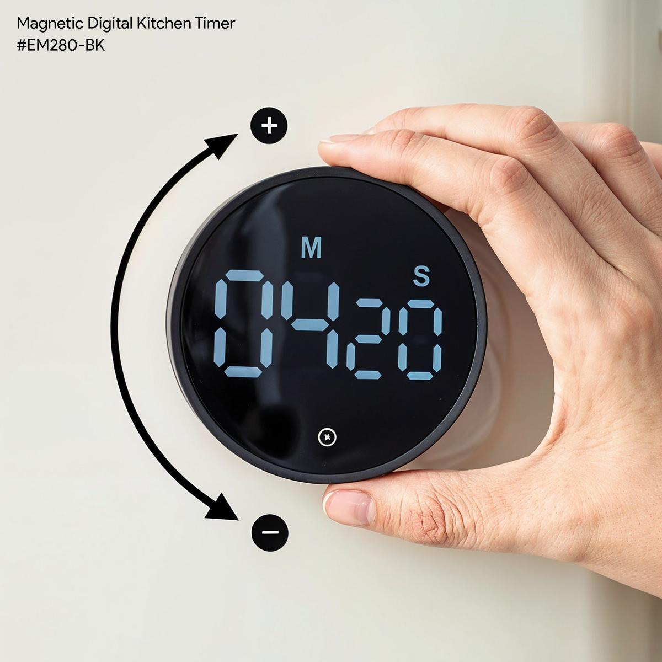
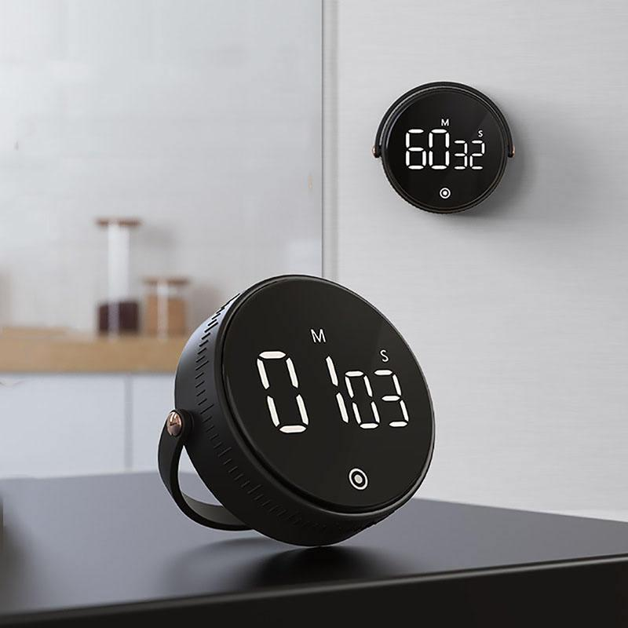
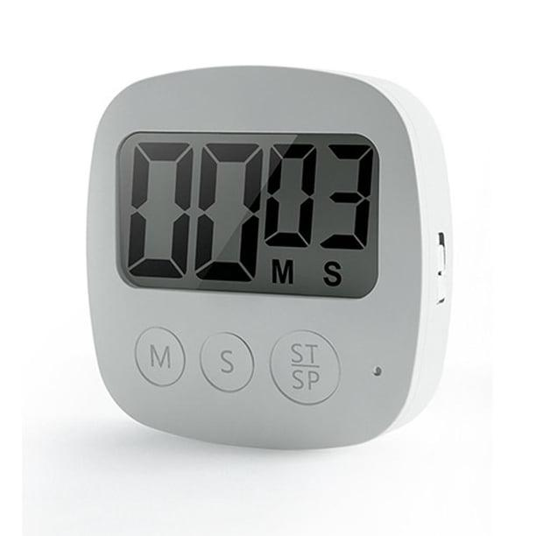
Description
Designed specifically for cooking and baking.
Features
- Countdown function
- Loud alarm
- Compact design
Applications
- Kitchens
- Restaurants
- Bakeries

4. Laboratory Timer
# Source: AI Source: Provided by: [Data Path: Persons Table -> ID Column: 1, Name_En Column: Motasem Essam] -> From: [ChatGPT] on [7/17/2026]


Description
Provides precise timing for scientific experiments.
Applications
- Chemistry
- Biology
- Physics
- Medical laboratories

5. Industrial Programmable Timer
# Source: AI Source: Provided by: [Data Path: Persons Table -> ID Column: 1, Name_En Column: Motasem Essam] -> From: [ChatGPT] on [7/17/2026]
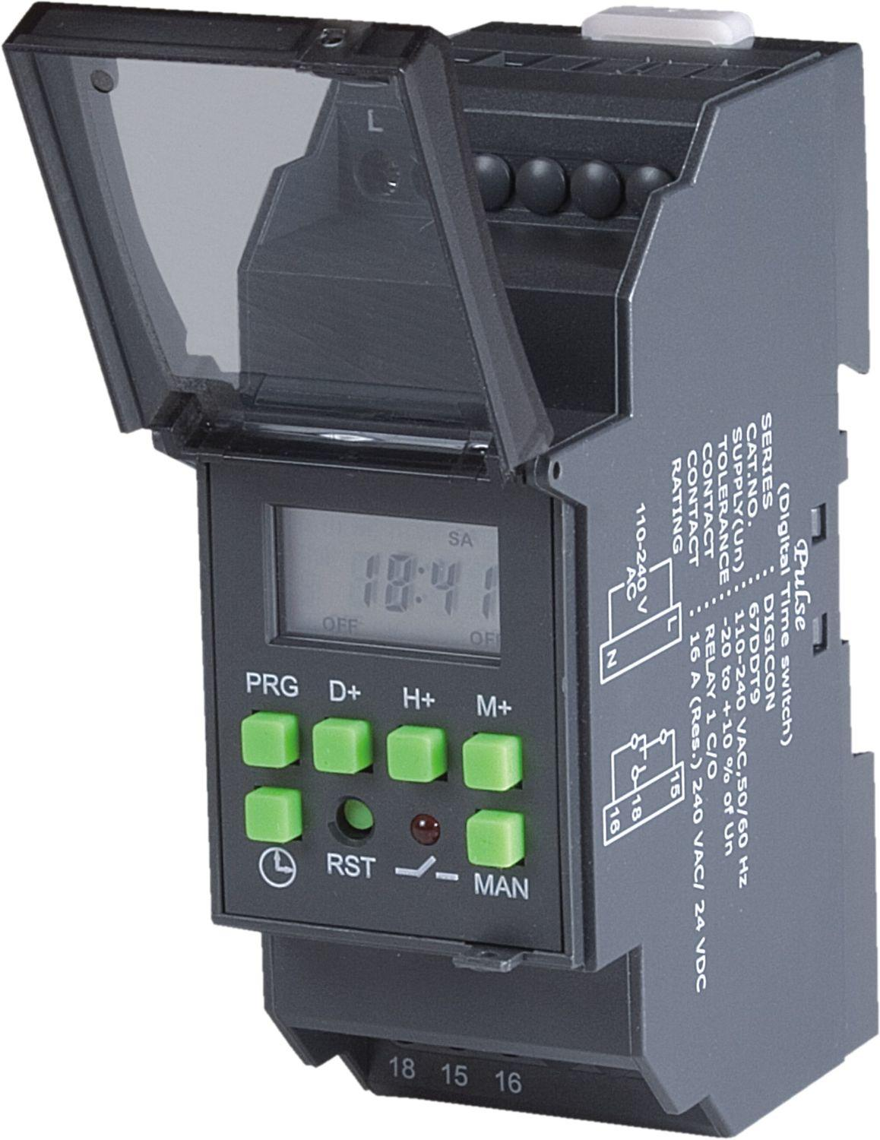
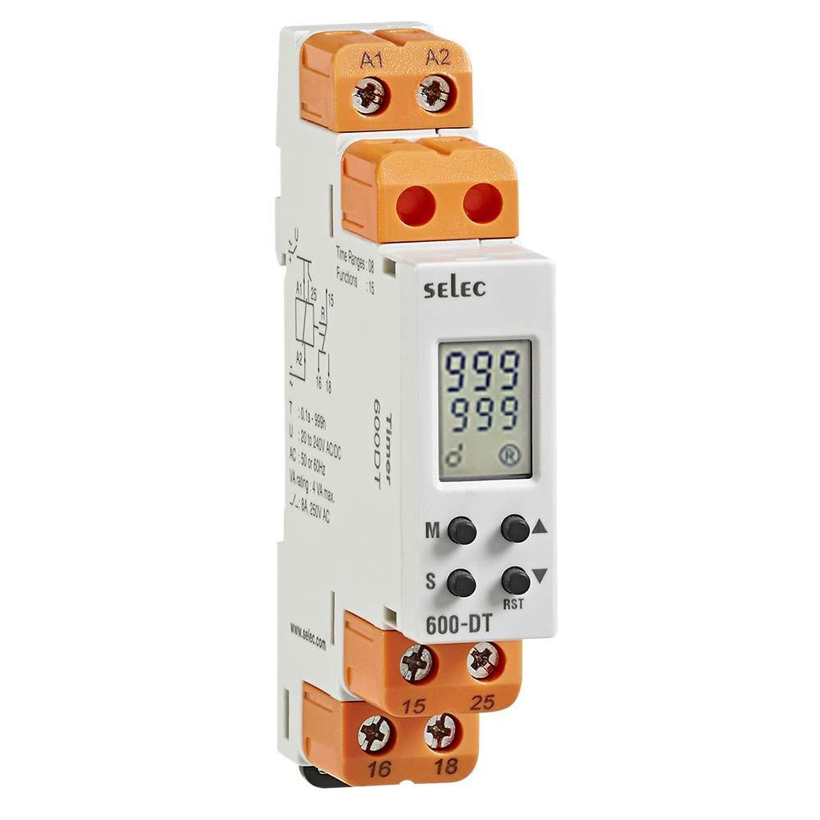
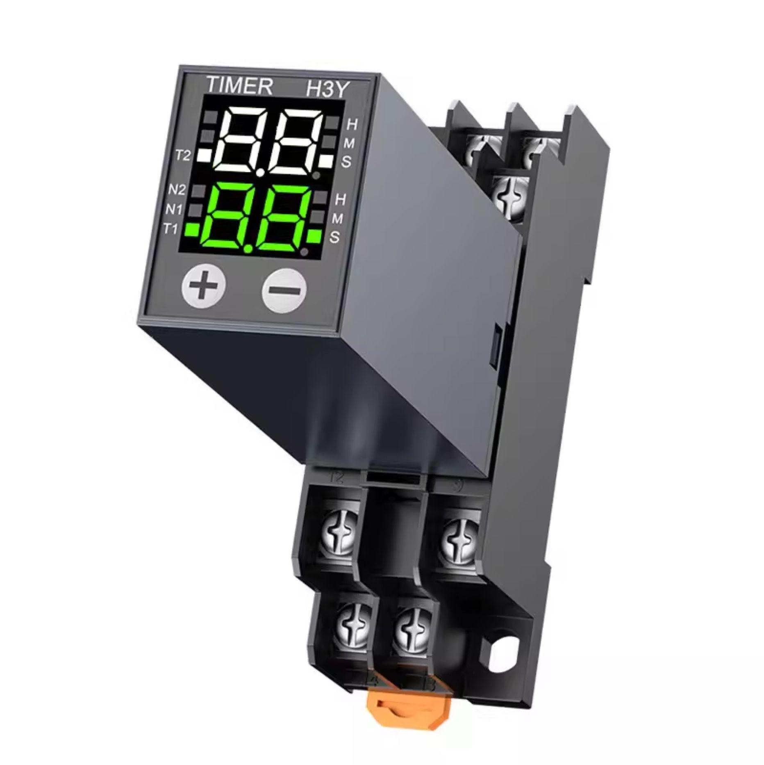
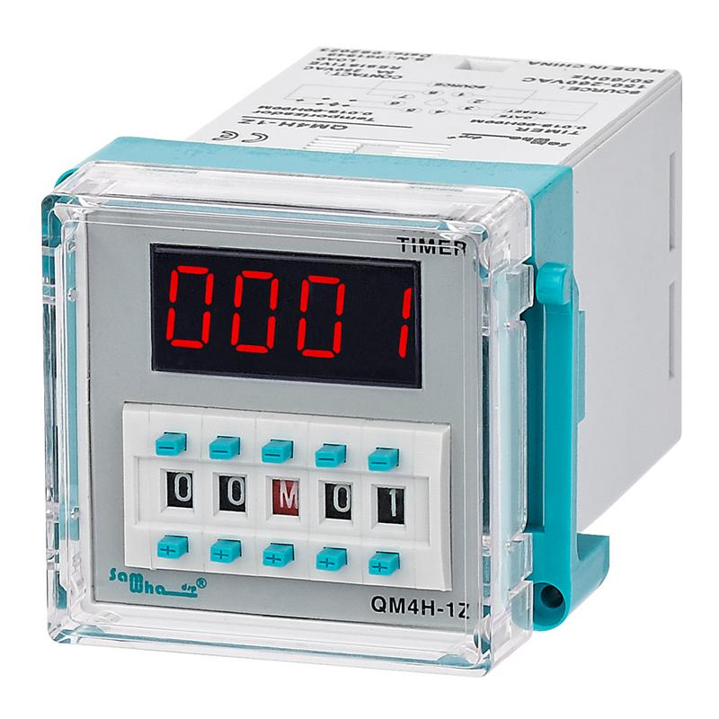
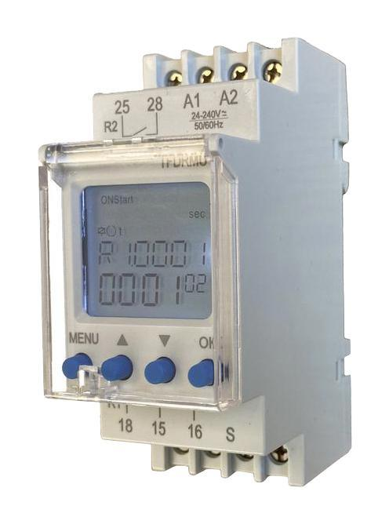
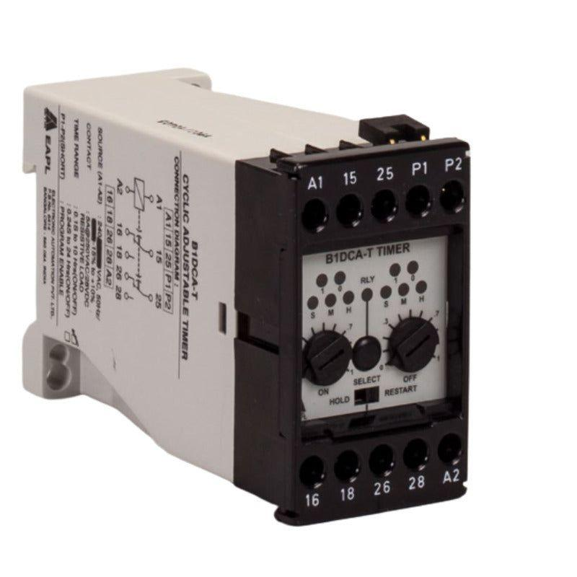
Description
Controls electrical equipment automatically according to preset timing sequences.
Features
- Programmable schedules
- Automatic switching
- High reliability
Applications
- Manufacturing
- Industrial automation
- HVAC systems
- Irrigation systems

6. Interval Timer
# Source: AI Source: Provided by: [Data Path: Persons Table -> ID Column: 1, Name_En Column: Motasem Essam] -> From: [ChatGPT] on [7/17/2026]
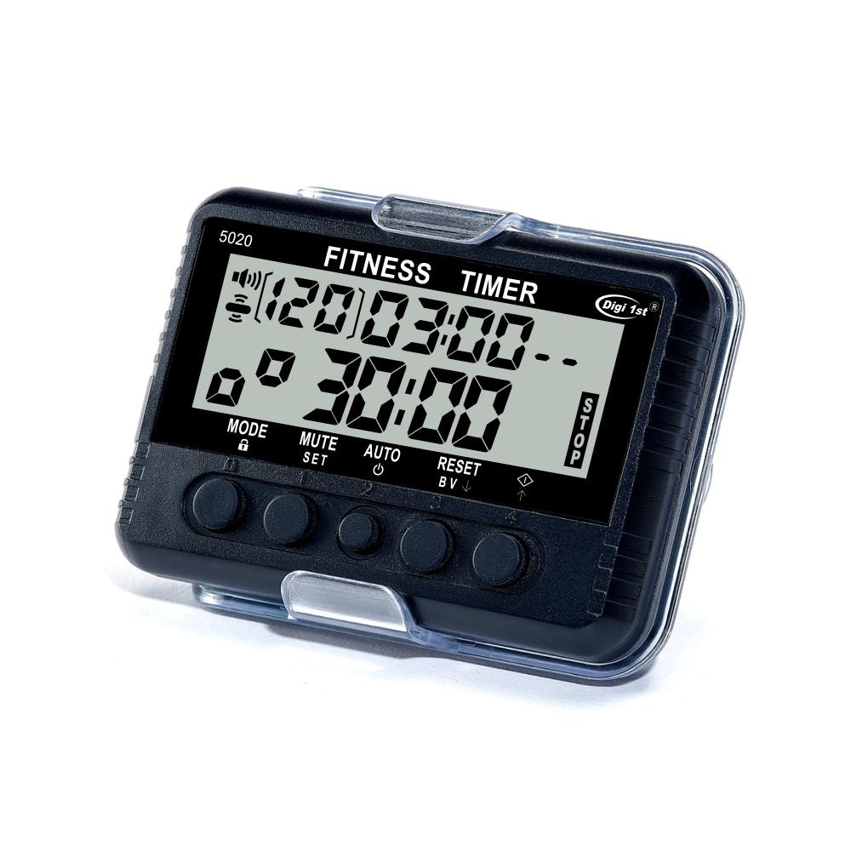
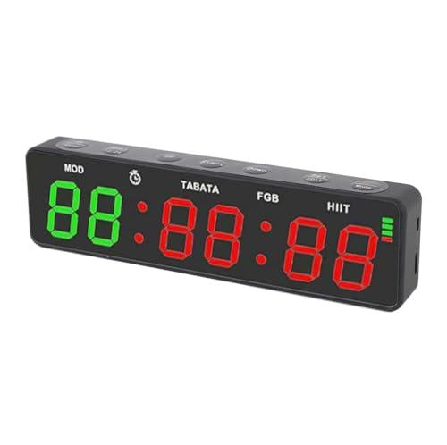
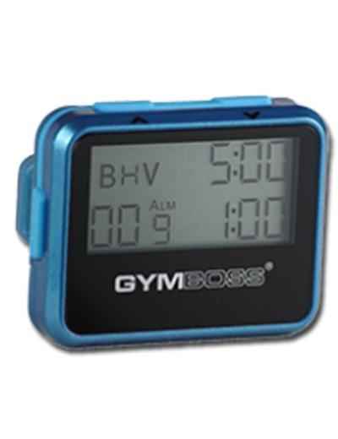
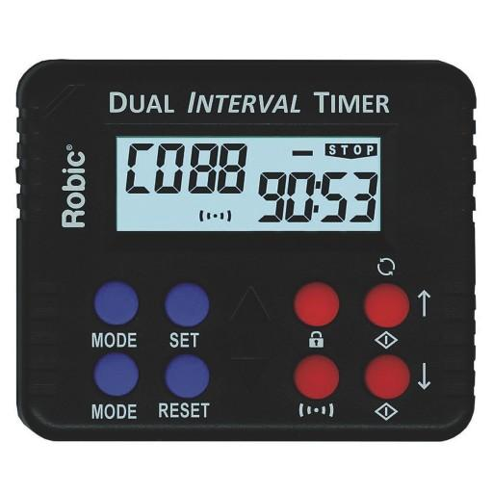
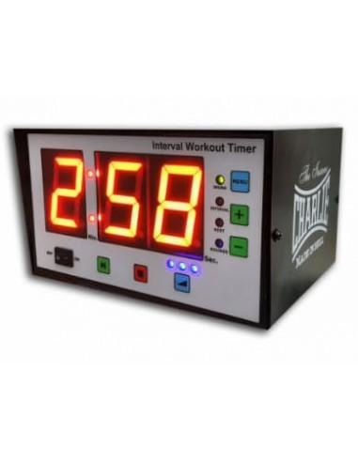
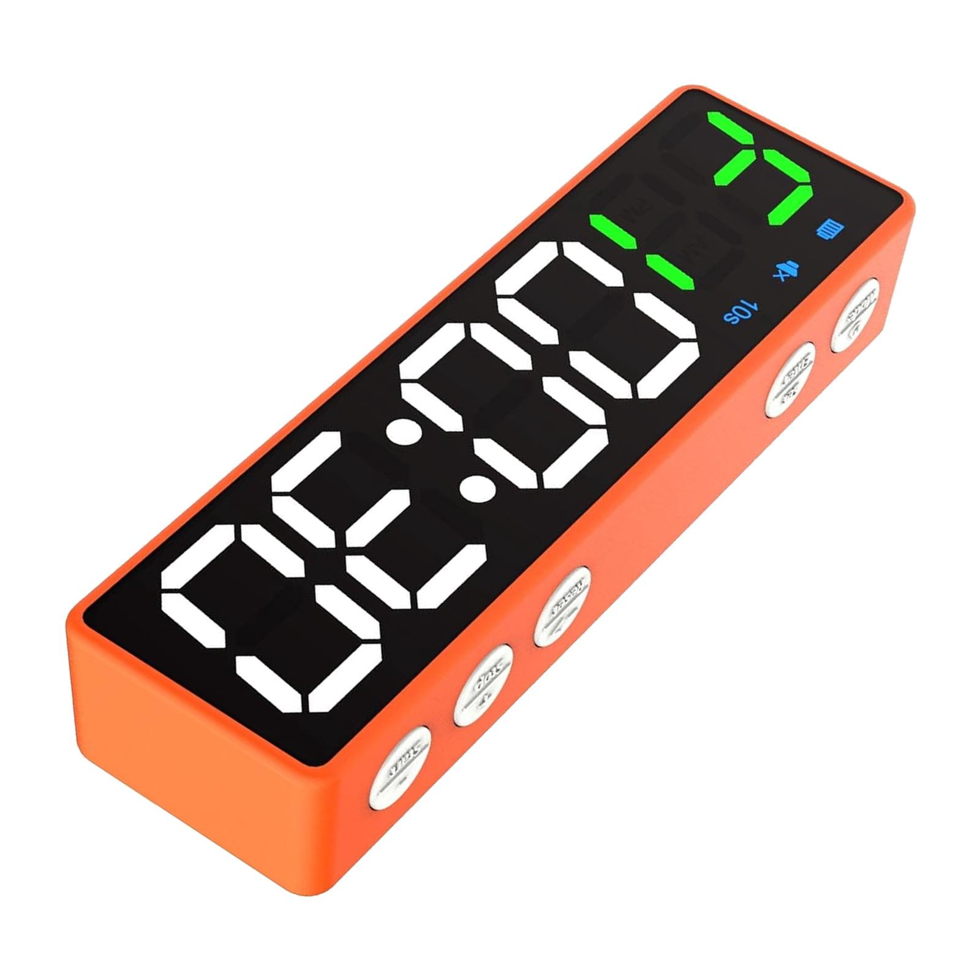
Description
Alternates between work and rest periods.
Applications
- Fitness
- Athletics
- HIIT training
- Coaching
7. Electronic Timer
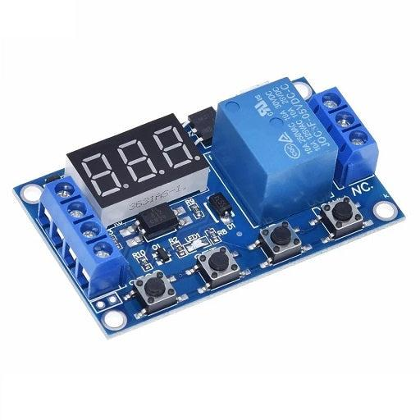
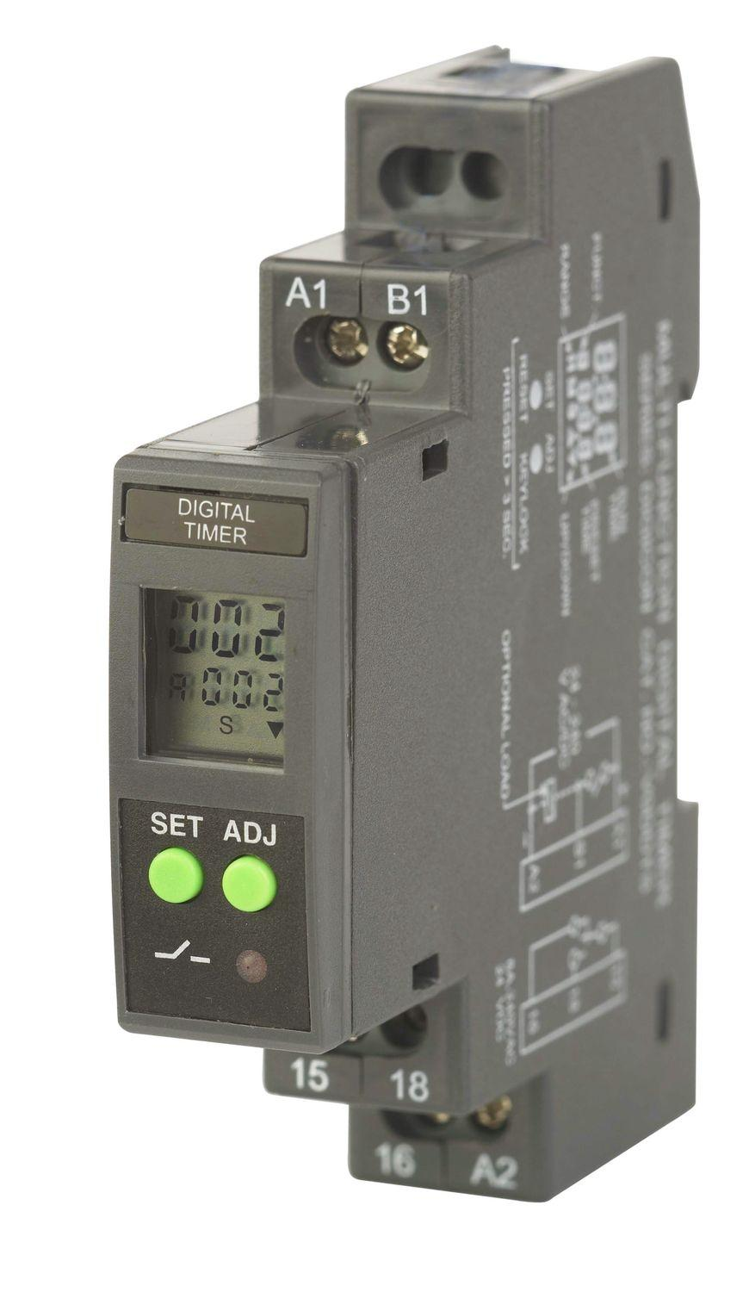
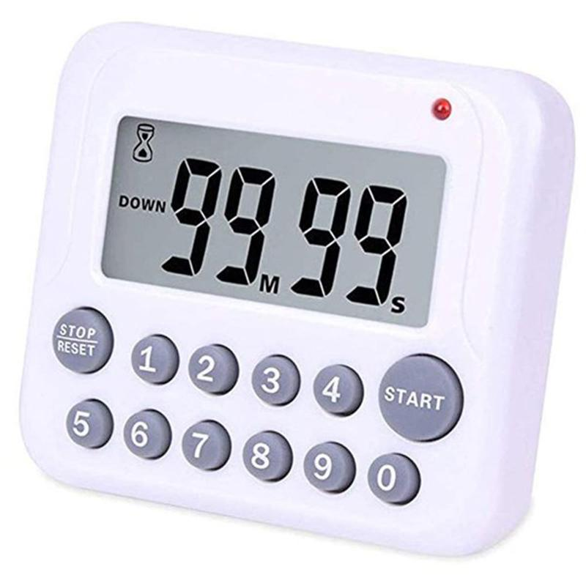

7. Electronic Timer
# Source: AI Source: Provided by: [Data Path: Persons Table -> ID Column: 1, Name_En Column: Motasem Essam] -> From: [ChatGPT] on [7/17/2026]
7. Electronic Timer



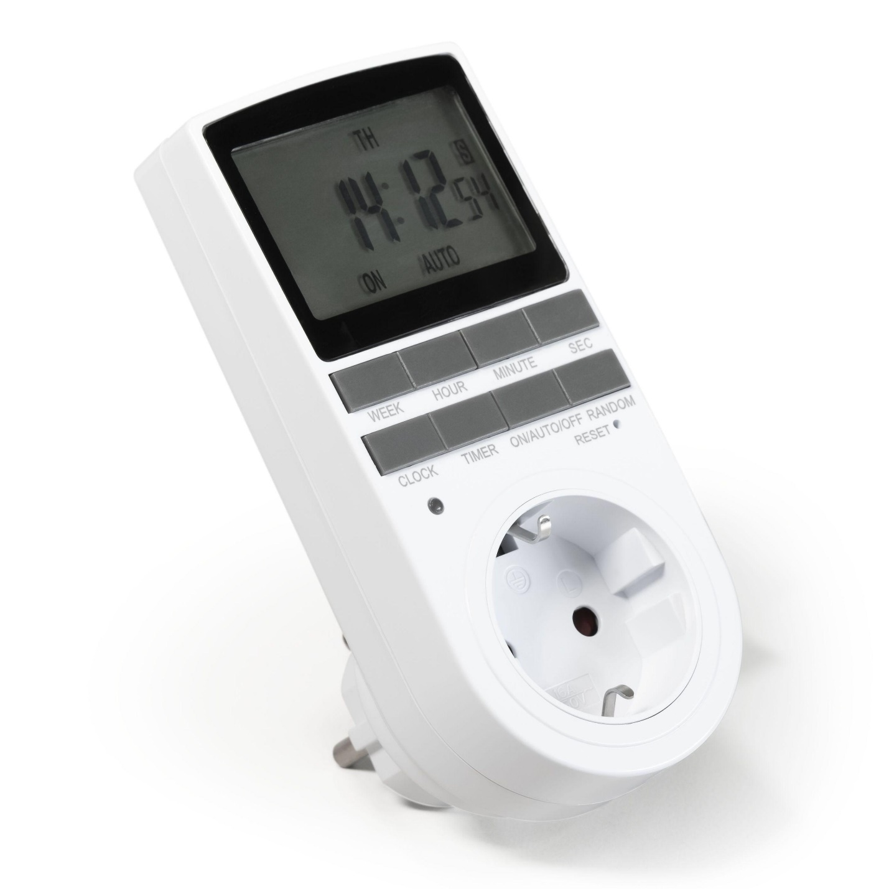
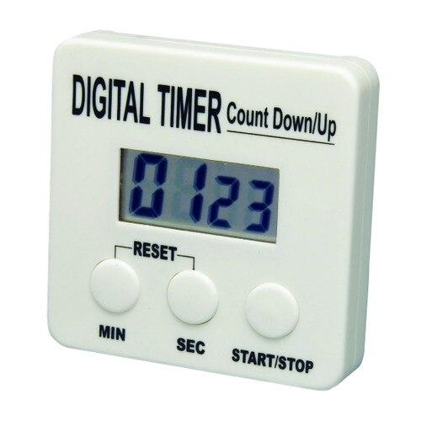
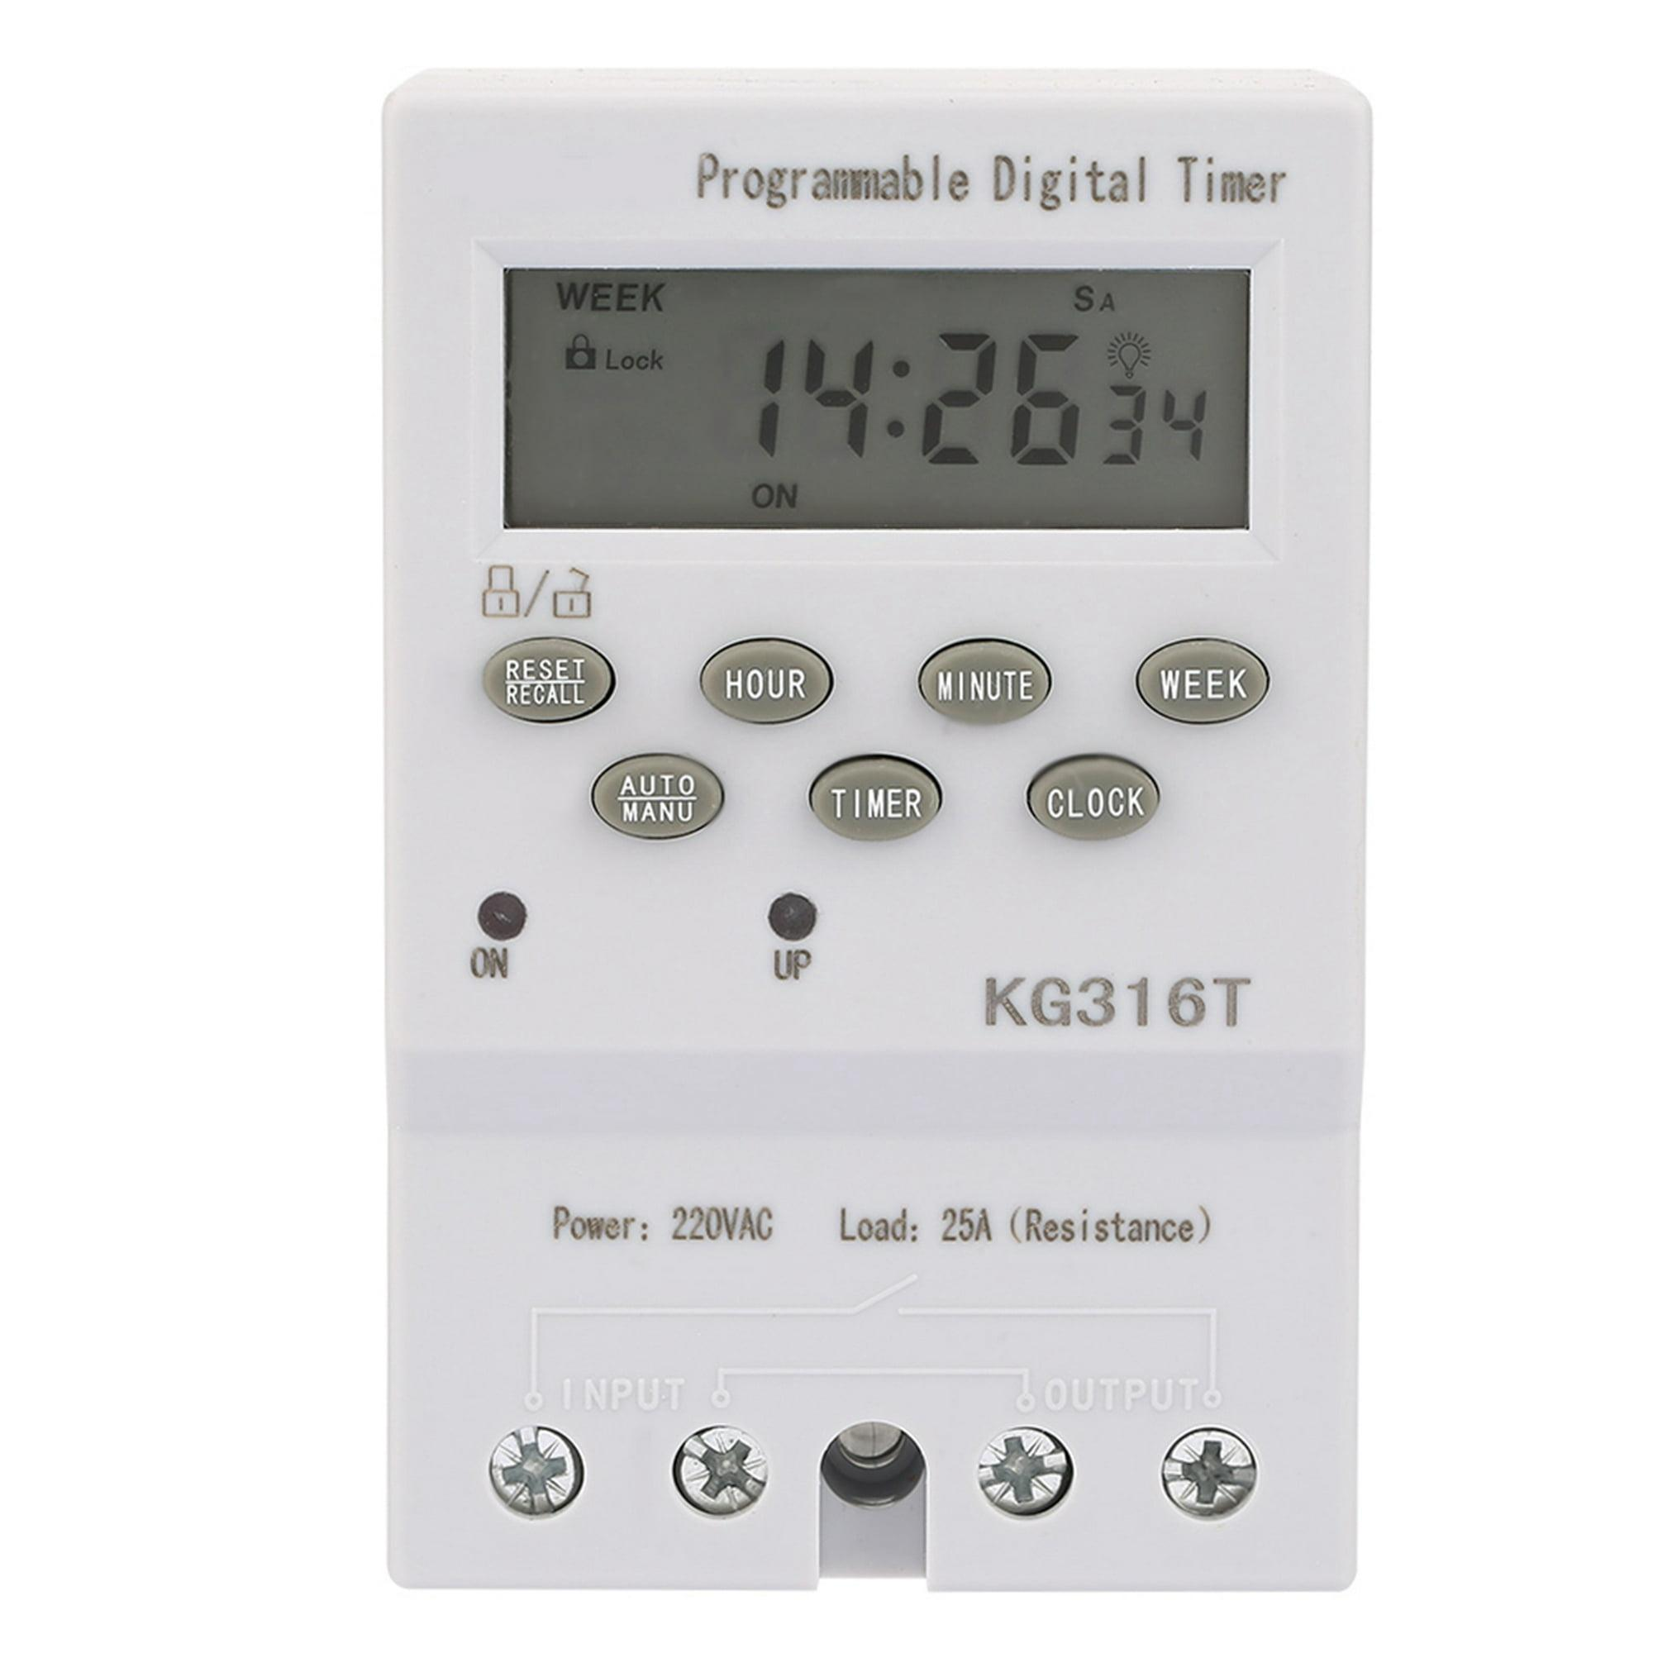
Description
An Electronic Timer uses electronic circuits and timing components (such as integrated circuits, quartz oscillators, or microcontrollers) to measure or control time intervals with high precision. Unlike purely mechanical timers, electronic timers operate without springs and typically provide more accurate and reliable timing.
Features
- High timing accuracy
- Electronic timing circuits
- Adjustable countdown or delay settings
- Digital or LED/LCD display (on many models)
- Can control electrical circuits automatically
- Long operational life with minimal mechanical wear
Applications
- Industrial automation
- Electrical control panels
- Manufacturing equipment
- Laboratory instruments
- Scientific experiments
- Home appliances
- Lighting control systems
- Pump and motor control
- HVAC systems
- Electronic devices

Measuring Units
# Source: AI Source: Provided by: [Data Path: Persons Table -> ID Column: 1, Name_En Column: Motasem Essam] -> From: [ChatGPT] on [7/17/2026]
Timers typically display:
- Hours (h)
- Minutes (min)
- Seconds (s)
Some high-precision timers also display:
- Tenths of a second (0.1 s)
- Hundredths of a second (0.01 s)
- Thousandths of a second (0.001 s)

Measuring Range
# Source: AI Source: Provided by: [Data Path: Persons Table -> ID Column: 1, Name_En Column: Motasem Essam] -> From: [ChatGPT] on [7/17/2026]
Typical ranges:
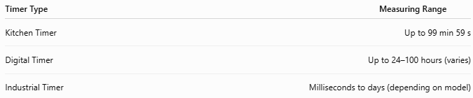
Timer Type | Measuring Range
Kitchen Timer | Up to 99 min 59 s
Digital Timer | Up to 24–100 hours (varies)
Industrial Timer | Milliseconds to days (depending on model)

Resolution
# Source: AI Source: Provided by: [Data Path: Persons Table -> ID Column: 1, Name_En Column: Motasem Essam] -> From: [ChatGPT] on [7/17/2026]
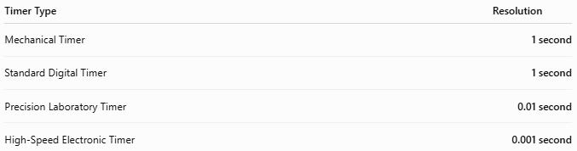
Timer Type | Resolution
Mechanical Timer | 1 second
Standard Digital Timer | 1 second
Precision Laboratory Timer | 0.01 second
High-Speed Electronic Timer | 0.001 second

How to Use a Timer
# Source: AI Source: Provided by: [Data Path: Persons Table -> ID Column: 1, Name_En Column: Motasem Essam] -> From: [ChatGPT] on [7/17/2026]
- Turn on the timer (if electronic).
- Set the desired duration.
- Press Start.
- Allow the timer to count down.
- When the timer reaches zero, it will usually sound an alarm or trigger an output.
- Reset the timer for the next use.

Example
# Source: AI Source: Provided by: [Data Path: Persons Table -> ID Column: 1, Name_En Column: Motasem Essam] -> From: [ChatGPT] on [7/17/2026]
Preset time:
15 minutes
Display sequence:
- 15:00
- 10:30
- 05:00
- 00:10
- 00:00 → Alarm sounds

Accuracy
# Source: AI Source: Provided by: [Data Path: Persons Table -> ID Column: 1, Name_En Column: Motasem Essam] -> From: [ChatGPT] on [7/17/2026]
Accuracy depends on:
- Quartz oscillator quality
- Electronic circuitry
- Calibration
- Battery condition
Digital timers generally provide much higher accuracy than mechanical timers.

Sources of Error
# Source: AI Source: Provided by: [Data Path: Persons Table -> ID Column: 1, Name_En Column: Motasem Essam] -> From: [ChatGPT] on [7/17/2026]
Instrument Errors
- Weak battery
- Quartz oscillator drift
- Mechanical wear
- Electronic malfunction

User Errors
- Incorrect time setting
- Failure to start the timer
- Pressing the wrong button

Environmental Errors
- High temperature
- Moisture
- Vibration
- Power interruptions (for mains-powered timers)

Applications
# Source: AI Source: Provided by: [Data Path: Persons Table -> ID Column: 1, Name_En Column: Motasem Essam] -> From: [ChatGPT] on [7/17/2026]
Timers are used in:
- Cooking
- Baking
- Scientific laboratories
- Manufacturing
- Industrial automation
- Medical procedures
- Sports training
- Education
- Irrigation systems
- HVAC control

Advantages
# Source: AI Source: Provided by: [Data Path: Persons Table -> ID Column: 1, Name_En Column: Motasem Essam] -> From: [ChatGPT] on [7/17/2026]
A timer:
- Measures fixed time intervals accurately.
- Is easy to operate.
- Provides automatic alerts.
- Supports automation in industrial systems.
- Is available in both mechanical and digital versions.

Limitations
# Source: AI Source: Provided by: [Data Path: Persons Table -> ID Column: 1, Name_En Column: Motasem Essam] -> From: [ChatGPT] on [7/17/2026]
A timer:
- Must be preset before use.
- Mechanical timers are less accurate than digital models.
- Battery-powered timers require battery replacement.
- Power failures may interrupt electronic timers unless backup power is available.

Comparison with Other Time Measuring Instruments
# Source: AI Source: Provided by: [Data Path: Persons Table -> ID Column: 1, Name_En Column: Motasem Essam] -> From: [ChatGPT] on [7/17/2026]
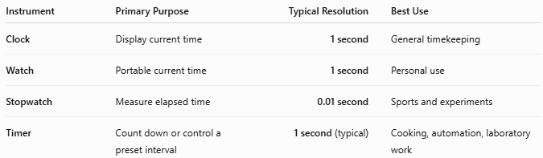
Instrument | Primary Purpose | Typical Resolution | Best Use
Clock | Display current time | 1 second | General timekeeping
Watch | Portable current time | 1 second | Personal use
Stopwatch | Measure elapsed time | 0.01 second | Sports and experiments
Timer | Count down or control a preset interval | 1 second (typical) | Cooking, automation, laboratory work

Care and Maintenance
# Source: AI Source: Provided by: [Data Path: Persons Table -> ID Column: 1, Name_En Column: Motasem Essam] -> From: [ChatGPT] on [7/17/2026]
To maintain reliability:
- Replace batteries when necessary.
- Keep buttons clean.
- Avoid dropping the timer.
- Protect from moisture.
- Store in a dry environment.
- Periodically verify timing accuracy for precision applications.

Common Mistakes
# Source: AI Source: Provided by: [Data Path: Persons Table -> ID Column: 1, Name_En Column: Motasem Essam] -> From: [ChatGPT] on [7/17/2026]
- Setting the wrong duration.
- Forgetting to start the timer.
- Ignoring low-battery warnings.
- Confusing countdown mode with count-up mode.
- Relying on a timer without checking its accuracy in critical applications.

Key Points
# Source: AI Source: Provided by: [Data Path: Persons Table -> ID Column: 1, Name_En Column: Motasem Essam] -> From: [ChatGPT] on [7/17/2026]
- A Timer measures or controls a preset time interval.
- Common types:
  - Mechanical Timer
  - Digital Timer
  - Kitchen Timer
  - Laboratory Timer
  - Industrial Programmable Timer
  - Interval Timer
- Most timers measure in hours, minutes, and seconds.
- Digital timers typically have a 1-second resolution, with precision models offering 0.01 s or 0.001 s.
- Timers are essential in homes, laboratories, manufacturing, medicine, sports, and automation.

Conclusion
# Source: AI Source: Provided by: [Data Path: Persons Table -> ID Column: 1, Name_En Column: Motasem Essam] -> From: [ChatGPT] on [7/17/2026]
A Timer is a versatile time-measuring instrument used to measure or control specific time intervals. Unlike clocks and watches that display the current time, timers are designed to count down from a preset duration or measure fixed intervals, often providing an alarm or control signal when the interval ends. Available in mechanical, digital, laboratory, industrial, and programmable forms, timers play a vital role in cooking, scientific experiments, industrial automation, healthcare, education, and sports, ensuring accurate timing and efficient process control.

